Name:_______________________________________ Date: ___________________ Period: _________
Unit 7: World War II (1940-1950)
Note/Assignment Sheet 1
www.whsmorris.weebly.com
Leading up to World War II:
Types of Government
Democracy | Nationalism | Totalitarian | Fascism | Socialism | Communism
The Rise of the Dictators
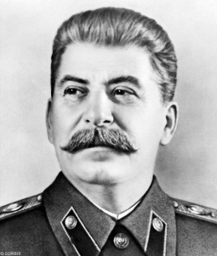
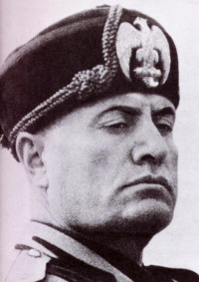
Russia
Stalin takes over USSR

Communism

Italy
Benito Mussolini

Fascism

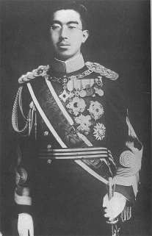
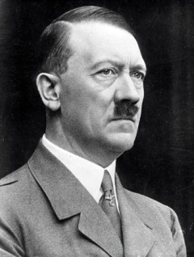
Japan
Militarists control Japan

Japan in China

Germany
Hitler

Nazi Germany

The United States Responds
- How SHOULD the US respond to the rise of dictators?

- How do you PREDICT the US responded to the rise of dictators?

How does America respond to the uprising of dictators in Europe? (pgs 271-272)

- The Nye Committee
Define:

What did it do to American support for WWII?

b. Legislating Neutrality –
Neutrality Act of 1935
2nd Neutrality Act
Neutrality Act of 1937
“Cash & Carry”
- Roosevelt's Internationalism
Internationalism

What’s wrong with neutrality according to FDR?

Why do you think FDR did NOT veto the neutrality acts even though he disagreed with them?

What events caused Roosevelt to become more of an internationalist?

