Name: _______________________________________ Date: _______________________ Period: __________
Unit 1: Review Beginnings (1400-1877)
Note/Assignment Sheet 3

How did America become “One Nation?”:
EXPANDING NATION
www.whsmorris.weebly.com

Manifest Destiny:

Louisiana Purchase | Annexation of Texas | War with Mexico

Trace the path of the four main groups that
moved westward
(Mormon Trail, Oregon Trail, California Trail, Texans).
1. Label each group’s trail, and include an
2. explanation of why they moved,
3. their destination, and the
4. significance of their settlement.

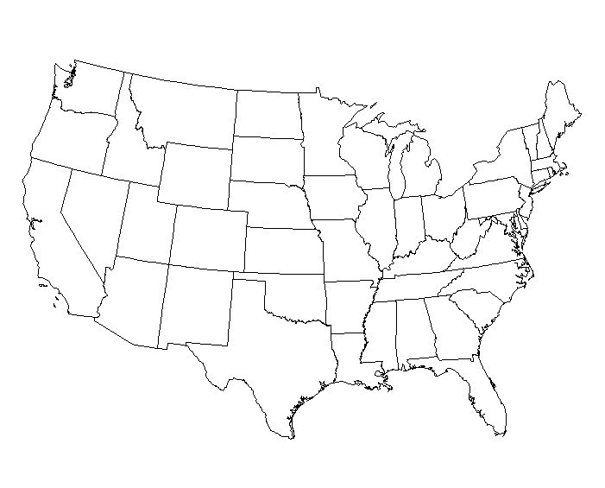

Primary Source Activity #1
Indian Removal
Trail of Tears – 1942 Painting (Write down what you see)

Document A: Jackson

- (Sourcing) What do you already know about President Jackson’ feelings about Indian Removal? What do you predict he will say in this speech?

- (Contextualization) Why does Jackson think the United States was better in 1830 than in 1609?

- (Contextualization) Why does Jackson think that the Cherokee will be better off in Indian Territory?

- (Close Reading) Why does Jackson think his policy is kind and generous?

Document B: Boudinot

- (Sourcing) Who is Elias Boudinot? What do you predict he will say about Indian Removal?

- (Contextualization) What was life like for the Cherokee in Georgia, according to Boudinot?

- (Contextualization) What does Boudinot hope will happen if Cherokees move west?

